Please bow your chins for the crispy prayer…

Our bacon, which art it burgers,
Fatty be thy meat,
Thy greasy plate,
Thy will be stuffed in the mouth
As it is in arteries,
Give us the crispy, delicious treat
and forgive us our fat asses,
As we grow more chins
and widen our waistlines,
and lead us not into dieticians,
But give us more bacon,
For thine is the crispy
the juicy, and the fatty,
Forever and ever,
‘Bacon’

Inspired by:
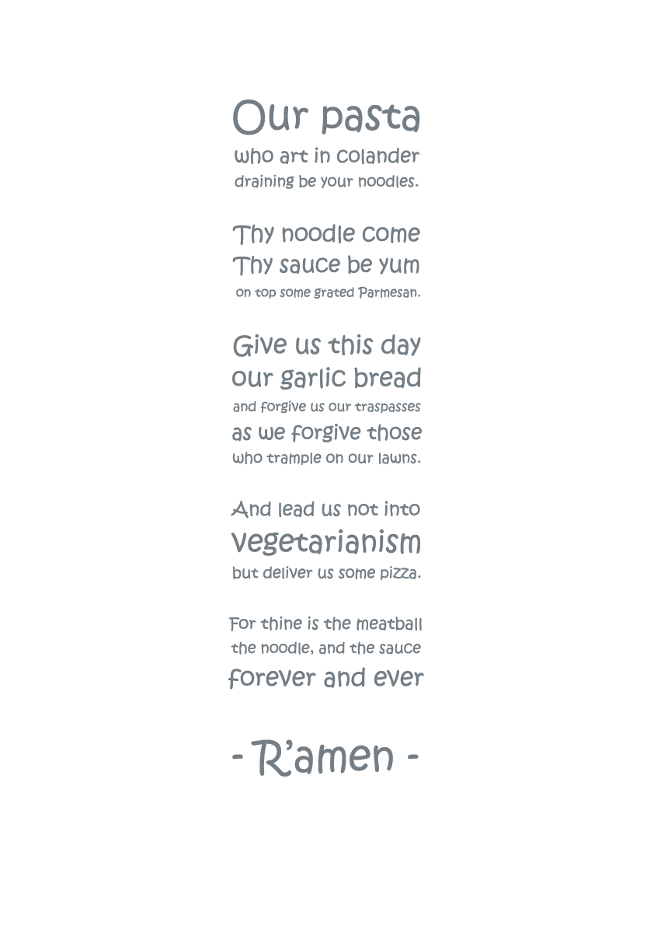

Based on:

Our Father, who art in heaven,
Hallowed be thy Name.
Thy Kingdom come.
Thy will be done on earth,
As it is in heaven.
Give us this day our daily bread.
And forgive us our trespasses,
As we forgive those who trespass against us.
And lead us not into temptation,
But deliver us from evil.
For thine is the kingdom,
The power, and the glory,
Forever and ever.
Amen.

